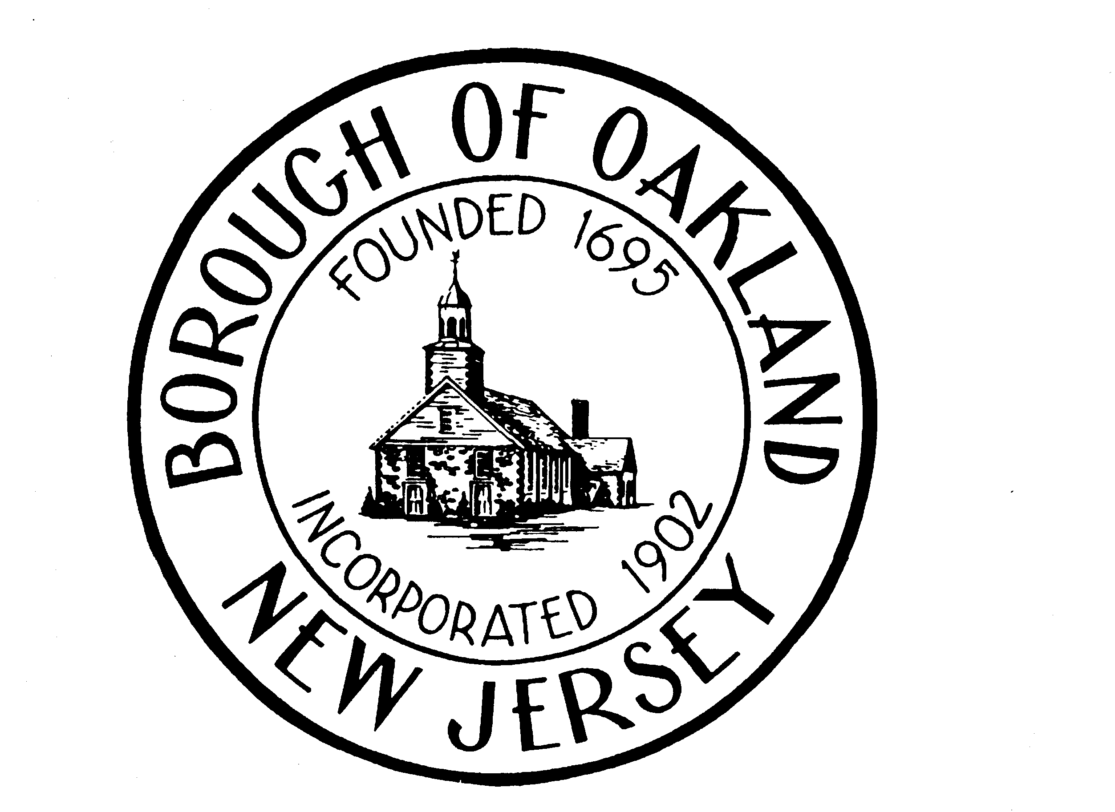

Authorization Agreement for ACH Direct Withdrawals For
Property Tax Payments and Water / Sewer Utility Payments

Resident: _________________________________________________
Address: _________________________________________________ Phone #: ____________________
Block: ____________ Lot: _____________ Qual: ____________ Acct #: ____________________

I (we) hereby authorize the Borough of Oakland, to initiate debit entries to my (our) checking or savings account indicated below at the depository financial institution named below, hereinafter called DEPOSITORY, and to debit the same to such account. I (we) acknowledge that the origination of ACH transactions to my (our) account must comply with the provisions of US law.

I (we) request that the Borough of Oakland process payments for the following:
Please check all that apply: _______ Quarterly Taxes _______ Water / Sewer Payments

Depository Name: _____________________________ Branch: ___________________
City: _____________________________ State: __________ Zip: ___________________

Routing Number: _____________________________ Account Number: _______________________________

This authorization is to remain in full force and effect until the Borough of Oakland has received & confirmed written notification from me (or either of us) of its termination in such time and in a manner as to afford the Borough of Oakland and Depository a reasonable opportunity to act on it.

Name(s) (Please print): _____________________________________

Signature: ________________________________________ Date: _____________________

NOTE: DEBIT AUTHORIZATIONS MUST PROVIDE THAT THE RECEIVER MAY REVOKE THE AUTHORIZATION ONLY BY NOTIFYING THE ORIGINATOR IN THE MANNER SPECIFIED IN THE AUTHORIZATION. INSUFFICIENT OR RETURNED ITEMS ARE SUBJECT TO A $20.00 FEE PER ORDINANCE # XX-#######

PLEASE NOTE THAT ORIGINAL REAL ESTATE TAX/SEWER UTILITY BILLS WILL STILL BE MAILED TO OWNER FOR ADVICE PURPOSES ONLY.

ATTACH YOUR PERSONALIZED VOIDED CHECK HERE AND RETURN TO:
Borough of Oakland
ATTN: Tax Collector
1 Municipal Plaza
Oakland, NJ 07436

