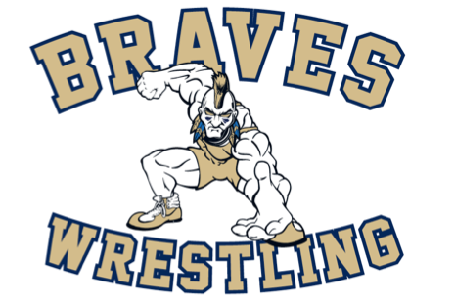
ARE YOU“BRAVE” Enough!
2022-23 Oakland/Franklin Lakes Wrestling Registration Notice
The Oakland Rec Commission will hold Online Registrations for the 2022-23 Season from September 27th - November 6th

To Register:
Oaklandrec.org

The season runs from week of November 28th – Late February.
Practices will be held on Mondays, Wednesdays, and Thursdays at:

NJ Sports House
12 Wright Way
Oakland, NJ 07436
Team meets are on Saturdays and some tournaments on Sundays.

Sign-Up Now! No Experience Necessary!
Grades K – 8th
Fee: $108.00

Separately, you must order your singlet individually. Please allow 4 weeks for processing.
To order your singlet:
https://5kount.com/collections/braves-wrestling/singlets

If you have any questions regarding wrestling please contact Oakland Wrestling Coach, Bobby Sherrow at braveswrestle@gmail.com

