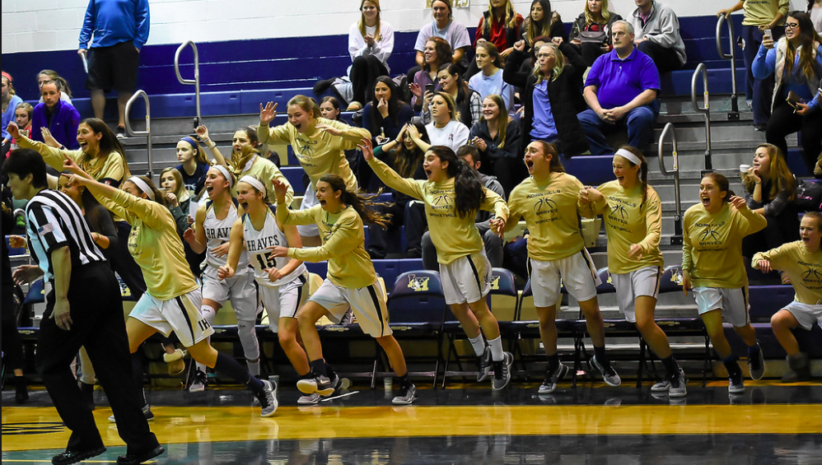
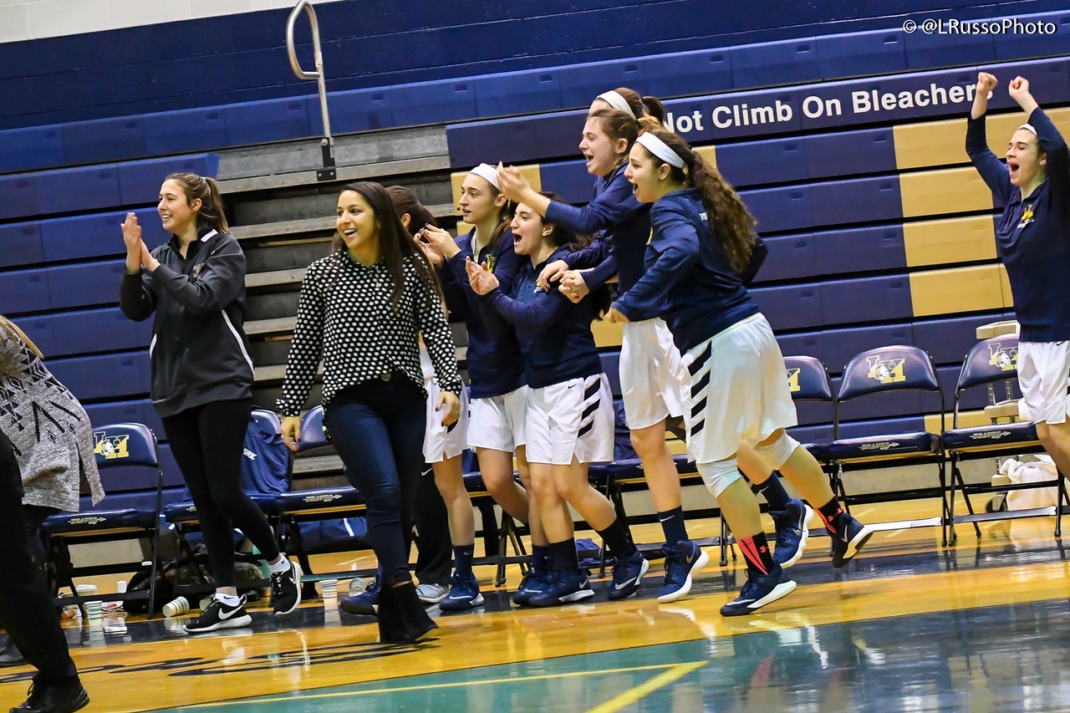
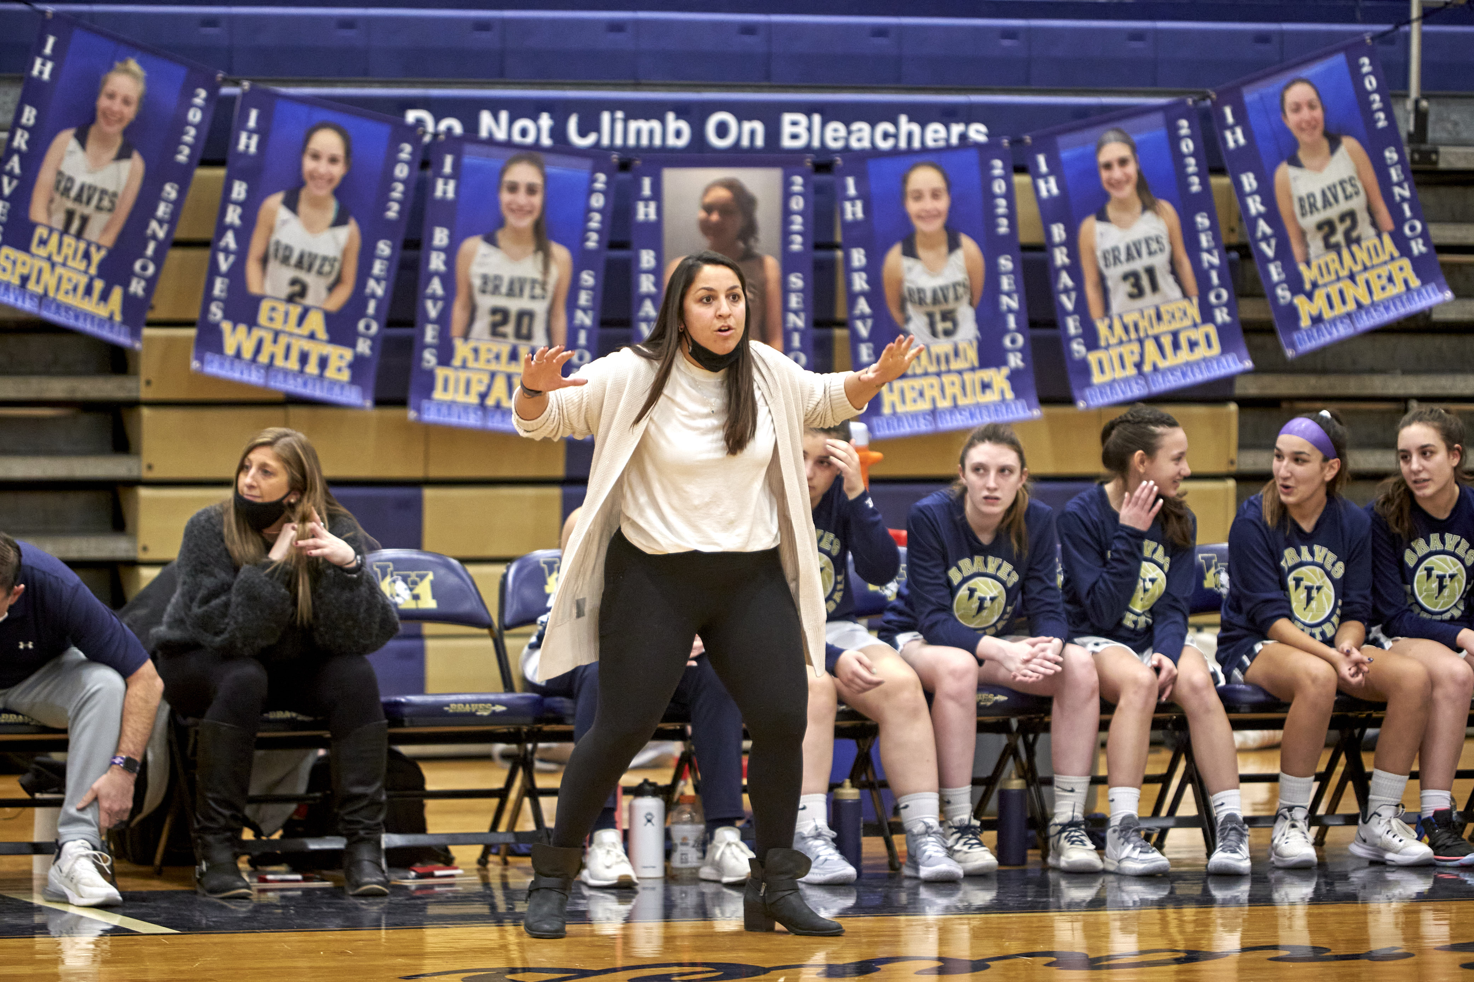
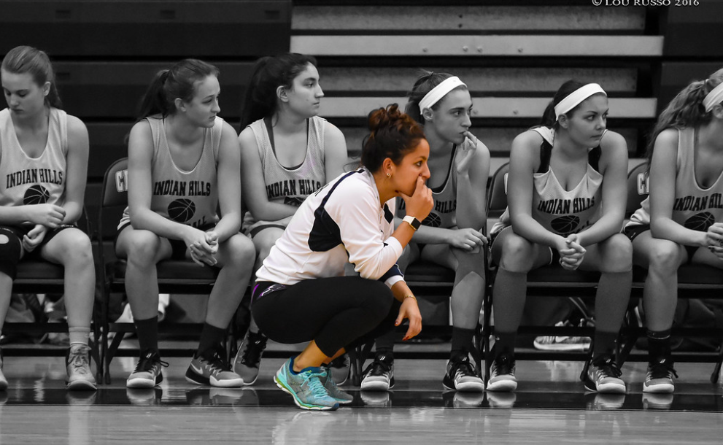
  - OAKLAND RECREATION PRESENTS

JULIE HALEDJIAN’S BASKETBALL CAMP
  - June 27th- July 1st – 9:00am-12:00pm
Where: Indian Hills High School – Upper Gym- June 27th- July 1st from 9AM-12PM
Instructors: Indian Hills Head Coach: Julie Haledjian Buccino
Indian Hills Assistant Coaches & The IHHS Basketball players
All Girls Entering 3rd – 9th Grade in September – Beginner to Advance Basketball Athletes
Cost: $200 –Payment online https://register.communitypass.net/OaklandBorough
Overview:
The camp emphasizes the fundamentals of basketball, including shooting, dribbling, passing, and defense through individual and team activities and competitions.
Julie Haledjian Buccino is the Head Girls Basketball Coach at Indian Hills High School. In her nine years as head coach, she earned her 100th win this past season and has helped many of her teams reach the county quarterfinals, with many appearances in the Bergen Record’s “Girls Top 25” list. With Coach Buccino at the helm, the Braves have made the state playoffs every season and finished with multiple players making the all-league and all-county teams.
Coach Buccino brings a wealth of experience through her own personal endeavors. She played college basketball at William Paterson University, finishing with a career record 87-24, with three NCAA tournament appearances. She was a two-time all-conference selection and 2nd team All-Metropolitan Basketball Writers Association pick. Coach Buccino also played overseas in the Pan-Armenian Games and was a Gold Medalist.

