Pleasureland Park
The History of Great Oak Park
Oakland, New Jersey
A Gold Award Project
Prepared by: Katherine Bonini
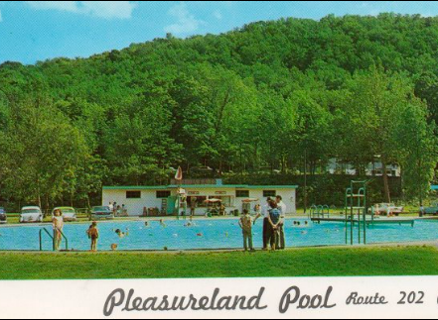
Table of Contents
A Bit About the Park
Pleasureland Pools
The First Aid Building
Pavilions
Pleasureland Stage
The Playground
Interview with Joe Moramarco
Interview with Mike Tersigni
Ways To Get Involved
Special Thanks To…

Visiting the park? Tell us what you think!
https://goo.gl/forms/M9v3TUpiuPs7l8hR2

Pleasureland Park was once a thriving community filled with swimming, dancing, laughter, and music. Due to some unfortunate circumstances, Pleasureland shut its doors as a park in 1985. In 2015, the area reopened as Great Oak Park, now a popular hiking park. Inside this booklet, you will find some information on a few of the remaining structures left in the area, as well as interviews with two of the previous park owners. Joe Moramarco was one of the first owners, and Mike Tersigni was the last owner before the park shut down.

A Bit About the Park
Pleasureland Park opened its gates before the 1950s, and people would come in from various places to picnic in the grass and swim in the river. Since then, two pools were built, as well as pavilions and other buildings around the park. As time went on, the club grew in popularity, and soon a couple thousand people attended each summer weekend. The days were filled with music from the jukebox, swimming in the pools, and eating on picnic blankets. Nights brought live music, dances, and other events for those at the park.
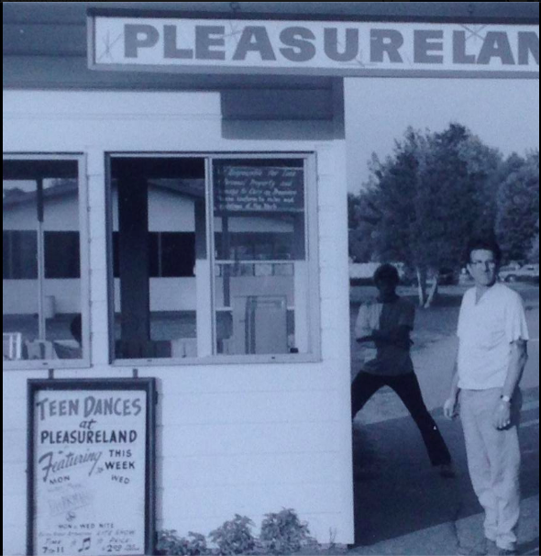
The Moramarcos were the original owners, and they built the pools, offering an alternative to swimming in the river. Joe Moramarco’s father, Dan Moramarco, had also built three pavilions in the park that were used as a playing venue for visiting bands, as well as a place to dance or hang out during such events. The Dragos had bought the park from the Moramarcos in the mid-1970s, and made minor changes to the park such as adding fencing around the pools and rebuilding a collapsed pavilion. A few structures remain behind from when the park was open. The pools were filled in and are now used as the parking lot, but the swingset, bandshell, pavilions, and first aid building are still visible around the park.
Unfortunately, August of 1985 brought hard change for the park. After a gunman attacked Muller’s Park next door to Pleasureland, the newspapers covered the event as having occurred in the ‘Pleasureland area,’ and the park lost a lot of popularity because of it. The park shut down, and was recently reopened as Great Oak Park in 2015. Today, the park has been turned into a hiking area, and is being cleaned up and further renovated as time goes on.

Pleasureland Pools
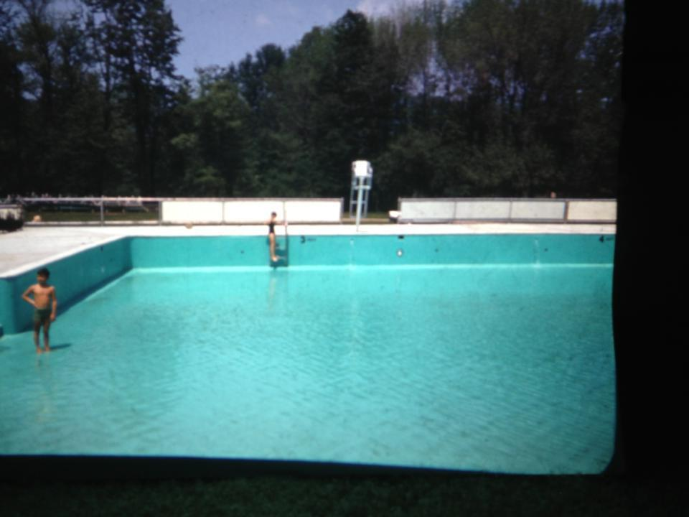
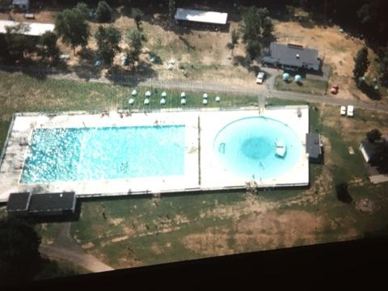
The first pool was built in the early 1960s by Dan Moramarco, Joe Moramarco’s father. It was a round ‘kiddie’ pool about 80 feet in diameter, and got to about seven feet deep in the middle. The larger, Olympic- sized pool was built soon after, about 75 by 100 feet and about 12 feet deep in the center. It was raised up so that the flood waters would not find their way in, and the lifeguard stands were placed on the platform. The pools were repainted blue every year, and both had graduated centers. There were always lifeguards all around the pools, and there were two big spruce trees right by the entrance to the bigger pool. The larger, rectangular pool had a big concrete deck on stanchions, featuring a high dive as well as two smaller dives that were very popular amongst the people coming to the park. The pool also had a slide and ropes going all the way around. There were no steps going into the pool, just ladders going around. The pools were one of the later additions to the park, but have been the most popular aspect since they were constructed.

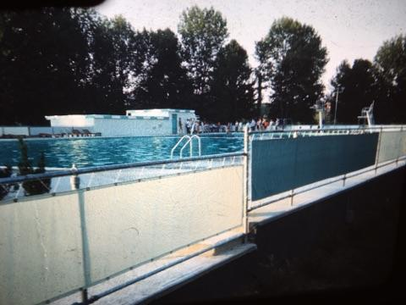
The First Aid Building
The first aid building in Pleasureland Park was a small building that was primarily used to treat small cuts and skinned knees. The building existed to administer basic first aid when necessary, but if anyone was seriously injured, the police or first aid squad would come. The building had a small cot and some medicine inside to be used for treatment. It was also a common hangout spot for lifeguards who were off-duty.
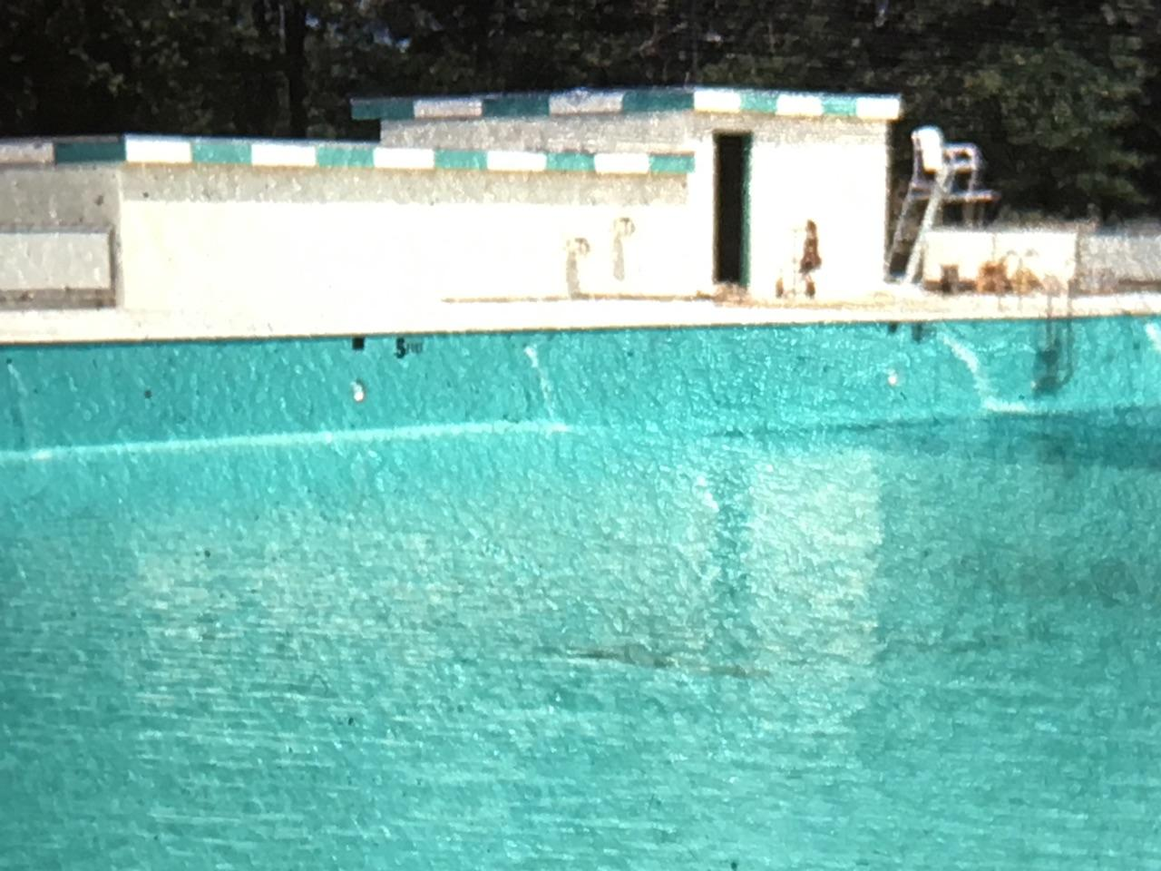

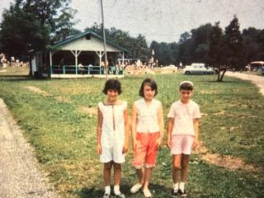
Pavilions
Known for containing the dance floor and band shell, the pavilions were another popular part of the park. The open, covered pavilions were built for dancing, music, or games that visitors wanted to participate in. Hundreds of kids would flock to Pleasureland in the evenings to hear music and to dance. The original pavilion was an older, smaller one that got knocked down in a particularly violent storm. The next one that was built was a lot larger, with a big roof, steps going in the side, and a large stage in the middle. There was a total of three pavilions, the biggest having a slant, shed-like roof while the rest had flat-beamed roofing. The big pavilion was about 60 feet long, featuring hardwood floors and a jukebox for dancing.

Pleasureland Stage
The stage was inside the pavilion, and many bands would come play. Big names such as Vanilla Fudge, The Turtles, Sam the Sham and the Farros, The Lovin’ Spoonful, Tommy James and the Shandels, The Circle, Red Rubber Ball, Buffalo Springfield, Blues Magoose, any group that came to New York, would come here and play. The groups would charge about $750 for a night, and they would play two or three 45-minute sets. As time went on, less bands played at the park, but the stage was still a popular place to go.
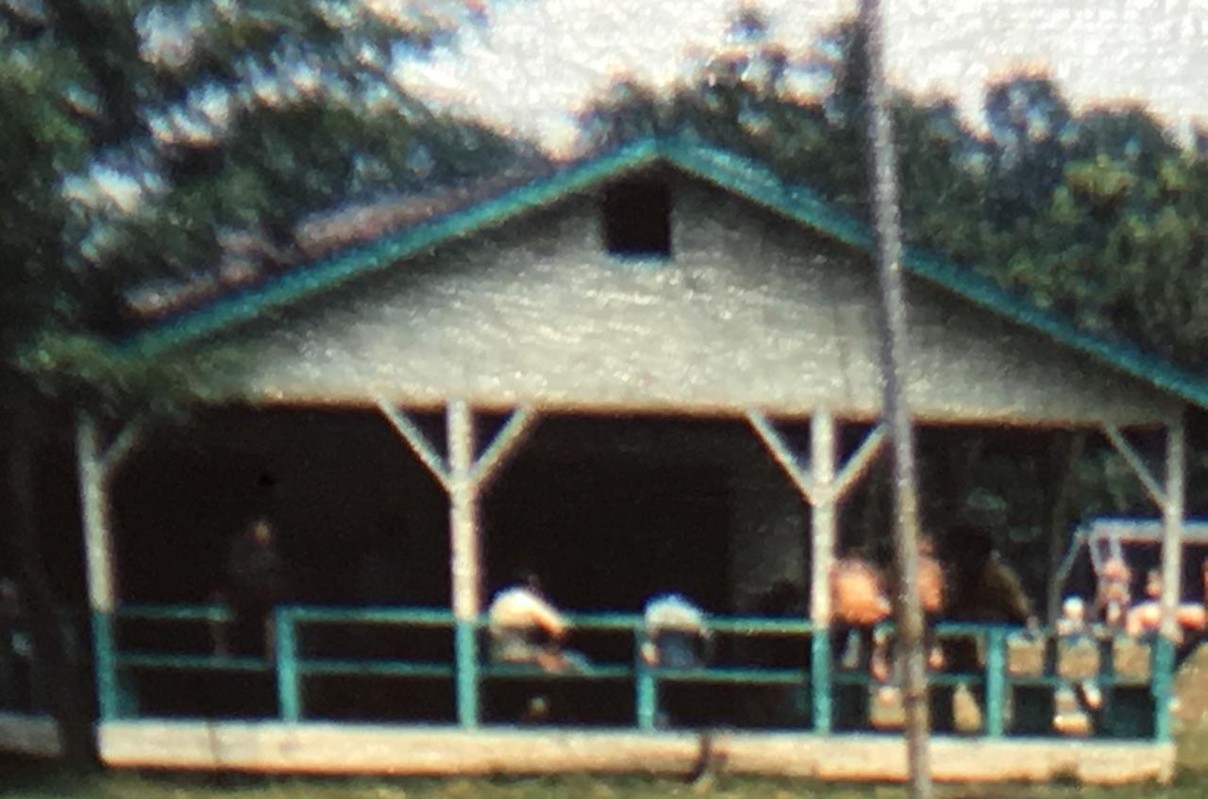

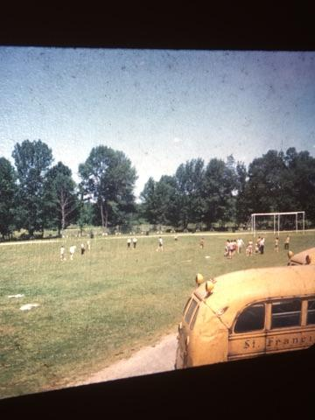
The Playground
Pleasureland Park had a couple of swing sets, as well as seesaws, a trapeze bar and rings, a giant stride (a metal pole with chains on it that you hold onto and run to spin around on it), and other playground equipment. The seesaws and giant stride were taken away for safety reasons, but the swing sets still remained. The swings were high, and had wooden seats before they were renovated. Today, only the metal poles holding the swings remains.
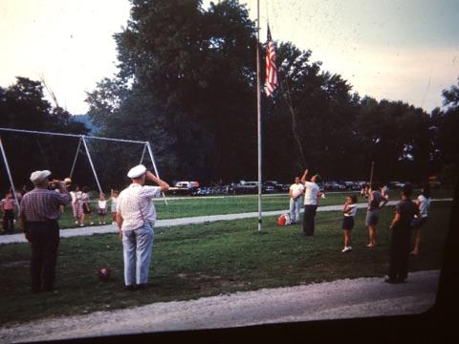
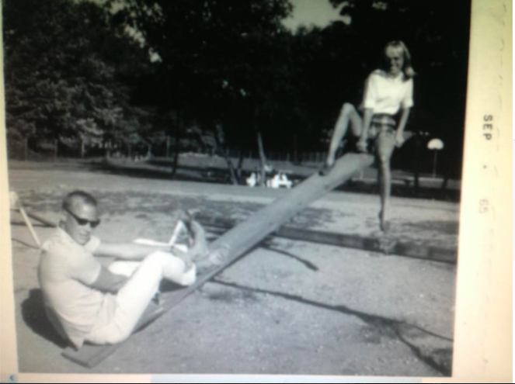

Interview with Joe Moramarco
How did Pleasureland get started?
Pleasureland was here way before my family ever bought it- my aunts, uncles, and parents. They bought it in the early 1950s. It was a swim club across the street by the river, and that’s how it started. It was more of a summer thing for people to come from New York and places like that, to come here in the country. When my father ran it, it was in the early ‘50s and everybody swam in the river. There was a bar, a snack bar, and a big pavilion, and people would come here for picnics and to hang out. Then it got bigger and bigger and they started getting people from New York in bus trips and business things. There was this huge field, but then my father decided to build the pools, so he built the round pool first, in the early ‘60s. The second pool was built soon after, which was the olympic-sized pool, and they raised that up so the flood waters wouldn’t come in. Then they put in the lifeguard stand and the filter house, and it just grew. Then they had the snack bar, bathrooms, and three pavilions. The funny thing is, I used to be a lifeguard as I grew up, and I used to guard the pools with some of the other guys, and we never, ever had problems with people at all. At the picnics, people would be drinking, but they’d have beef-steaks and their regular annual picnic for the summer, and there was hardly any trouble. It was really nice, it had was a good atmosphere. My father had a lot of membership, so he got a lot of people from town, and from other towns that came in, and they would buy a membership for the season, and they’d come to the pool every day with their kids. It just grew, until the ‘70s, and he decided to sell it.

What was it like growing up here?
My father used to come here, he used to go to Crestwood Lake in Allendale. He used to go to places like that, and somehow he found this place that was for sale, and decided to buy it. So, they bought it and my father and my uncles kept building it up and doing more to it, and it turned into a really nice place. It was probably one of the better places around, growing up here. We lived in a little summer cottage that they had on the other side of the river over on the side of the road, and we lived there for a year and a half. Then my father built another house and we lived in that summer cottage until he had built the other house. I kind of grew up here from the ‘50s to the late ‘70s. And it’s 2016, and I’m still here [chuckles]. It was good, it was a good experience, and it was great for a lot of people that came here too. They enjoyed the pools, and they were always well taken care of. Every year, we used to get all of the tables, bring them out and set everything up, paint the pools, plant a lot of trees. Some of the pine trees are still here, and there is still one of the blue spruces still alive. There were two big spruces right at the entrance to the pools, and then there was one by the flagpole. When we planted those, they were about four feet tall. It wasn’t like my dad just built the place and looked to make money- he wanted to make it nice.
My cousins and everybody who was here, we would all come clean up the park and work at the snack bar. They had a big snack bar, my favorite was yoohoo, [and there was] every candy you could possibly eat. We used to have Drake’s Cakes, so they would have the Drakes Cakes, and we’d take them and put them on the grill. We’d grill them, and then we’d take Dolly Madison Ice Cream, because they had little cups of Dolly Madison Ice Cream, chocolate, and we’d put it on top of that, and that was our dessert. Cake and ice cream. *chuckles* It was a good experience growing up here and everything… it was fun, we had a good time. We used to have an old international pickup truck, and I kind of learned sitting on my father’s lap how to drive. Then I started to touch the pedals, and as soon as I could start driving, I was driving back and forth across the street, delivering beer, soda, and ice to the picnics. It was good, it was a lot of good experiences.
Before we had the pools, we would swim in the river. So, one day they had boats down at the little dock over there, by the bridge. Well, somebody stole one of the boats, and the guy is paddling it with his hands down the river. My father’s yelling at him, and they told him to bring the boat back. So finally, I don’t know how the guy got it back, if they either went out to get him, or if the guy came back. Well, he started a fight with my father, and he bit my father in the arm. My aunt came along with a frying pan, and hit the guy on the back of the head. The guy got knocked down, and that was it. I was still very little, and the police came and took him away.

What were the summer houses like?
Across the road from the entrance to Pleasureland, there’s a road that goes down there. It was all the bungalows- they were all summer houses- but people lived in them year-round. What happened was, they would be rented out. My father had three or four houses there.
There were more houses across the river, before they redid the whole river and changed everything around. All those little houses in there were all summer homes. On the corner by the bridge, where the Doty Road bridge was, there was a little log cabin. A family used to come there all summer long every year from New York City. They would come every day and swim in the pool. I’ll never forget them because I like to fish, and one day, the husband came back and brought me a reel, a Mitchel300 reel. I still have it, it’s got to be from the late ‘50s. He gave me this rod and the reel, because he liked that I fished. I used to fish on his property, on the riverbank there, and I’d fish over here. But the cabins were… as it got later in the year, they got more people that lived in them year-round, instead of just coming for a weekend or a week.

On average, how many people would come to the park every day?
On the weekends, it could be a couple thousand. Saturdays and sundays were pretty, pretty busy. Normally on a weekday when it was a nice, sunny day, everyone would come in. It could be three or four hundred people. The road that goes all the way around the park would have cars parked on both sides of the street. But on the weekends, they could have a couple thousand. We never took count, though. I used to work the gate at night, when they had the dances. I don’t even remember what the prices of the dances were. They could’ve been five dollars or something just to get in.

Did you ever have problems with people while you were working?
I remember years ago, they were having issues with the black people that wanted to come into the park. The people had gone over to Muller’s (the park next to Pleasureland), and the cops came over and said, “Listen, we got like six car loads of people and they want to come into the park.” My father said, “Well, whatever.” I was working down at the gate that day, and I remember the cars come pulling in, and there were probably five or six people in each car. My father said hi to them, and we were standing there and he said, “Okay, uhm *counting* [two, four, eight, ten, twelve], that’ll be fourteen dollars to come in.” He didn’t say no to them and he wasn’t going to give them a hard time, so they said, “Oh, we can come in?” And my father said, “Oh yeah, you just gotta pay.” They decided they didn’t want to come in, so they turned and went back out again. They were coming in to hassle. Years ago, there weren’t a lot of black people that came out to swimming pools. Whenever we had a picnic, there were black people that worked at some of the companies that came here for the picnics, and they would come on the buses. But my father never ever, told somebody they couldn’t come in. It’s not a segregation type thing. We let anybody in, we didn’t care who they were. As long as they had money and they were good, he didn’t have a problem with them.
Most of the people were good, everybody had a good time, and the members were always fine and very loyal people. My father and my uncles were always good to everybody, and my aunts and my mother did all the cooking in the kitchen. They would make a lot of italian meals and this and that. Whatever they did, they did a good job, and there would always be [food] besides hamburgers and hot dogs and stuff like that.

Did [your mother and your aunt] cater?
No, they really wouldn’t do that. What actually happened was that they would have a company called Louis Nahas, a catering guy, and he would probably pretty much do most of the catering. He would come in with his truck, and six or eight guys, all clams and half shell, and stuff like that. One guy would be opening clams all day. They’d have these big long grills set up, and they’d be cooking filet mignon, beef-steak- they did an unbelievable job. What happened was, when they were cooking that, they’d always bring over two or three trays to my parents in the snack bar. So they really brought us food! Then we were all waiting for it because it was always so good and we didn’t have time to go over there and get it. But they had a great, great setup, and it was exceptional at the time. It was probably kind of a reasonable price for what they did over there, because in those days, everything was cheaper. But they had quality, quality food. It was just… I could have some of the beef-steak right now, you know?

Which part of the park was the most popular to visit?
The pool was, in the later years, in the ‘60s and ‘70s, because that’s where everybody went to go swimming. Plus, they had the high dive and the two smaller dives, so there were a lot of people who would come here just to use the diving boards. A lot of people loved the pools because they were clean, and it was a 12-foot Olympic-sized pool, 12 foot deep in the center. They even had racing lines in it, which sometimes they would have races, but they didn’t really do it on a regular basis. Everybody loved the pools and the park. People would like special places like in the back over behind where the filter house was, there was a grove back there. There was all maple trees, and they had it fenced in, with a split rail fence, and they had about 12 or 15 big long tables in there. People would come and they would want to get to that spot first. Or people would want to get to the river area, where there was all big huge (most of them are gone now, they probably fell down) oak trees that were on the side of the riverbank. When they redid the river, they took a lot of stuff out. But there were huge oak trees, and I can remember all the roots were coming out of the ground. You could climb down to the river, it wasn’t steep, but you’d have to go down and be careful climbing over these roots to get to the edge of the river to go fishing down there. It was something I can remember doing as a kid all the time, but people like it.

Was the small pool a wading pool?
No, it was like seven or eight feet deep in the middle, but it graduated. It was a round pool, and they had a big concrete dock, like a deck, on stanchions. It had a slide in the water on one side, and then it had ropes going all the way around. The whole pool graduated down from two and a half feet to eight feet. There were no steps going into that pool, it was just ladders, going around. You could actually step into the pool, from the deck, it was only two and a half feet. It wasn’t that deep, so it was good for little kids.

Did your father build the bigger pool, or did he have someone come do it for him?
My father built it. The big pool had steps going in on the shallow end, which was probably about four feet, and went all the way out to 12 feet. That was maybe 75 yards by 50, it was a pretty big pool. So what happened was, when I was a kid and they were building that pool, I had to help build it. I used to sit on the truck and cut the wire for the rebar that they were putting in the concrete for the bottom of the pool and everything. So, I cut it and we were doing whatever we were doing, it was crazy stuff. And then, later on they got the pool all done and they were doing the decks. I can remember one day, we just got done, they were pouring concrete for all the pool decks, all the way around. They would do one big piece, and then they would do another one.. It started to rain that night, or that day, so they put plastic over the top of it. And my one uncle, my Uncle Bart, he got caught in the rain, and he started running. He forgot that the concrete was there and he ran over the plastic onto the concrete. And he’s standing in the middle, and he’s going to my father, he’s yelling, “DANNY!” And my father looks at him and goes, “Oh, no.” They had to get him out of there, they had to take the plastic off, and they had to refloat the whole thing all over again, then put the plastic back on top of it.

Was there always a person on duty in the first aid building?
Yeah, well we had a bunch of lifeguards. There was a lot of different lifeguards, and usually there would be one or two lifeguards on the big pool. On a weekend, maybe you would have three. You’d have two over on each stand, then he’d have one standing in the middle between the two pools, and then there would be three lifeguards on the chairs, because they had three chairs. So there was always four or five lifeguards, six lifeguards or more on a weekend. It would be pretty busy on the weekends, you would have a couple thousand people here. You had a lot of people swimming, especially on a hot day, and people would just be laying on the deck. The lifeguard room was a hangout for some people at the time. A lot of the girls would hang around by the lifeguards, and it was like the craziest thing. I don’t know what the draw [was] for the girls to the lifeguards. There was always something going on, and it was good. People would come in with a cut or something like that, and they’d be sitting on a cot or whatever. As soon as they sat down, they scraped their leg or something, they’d put mecuricome or something on it, they’d put iodine on it, they’d be screaming, “Ah no no!” and yelling bloody murder. Then they’d put a bandaid on them, and it was just like, most of it was superficial stuff. We did have a couple times where, when the camp was here, they actually had a kid they pulled out of the water, who was underwater, we revived him, they brought him back again, which was really amazing. And then we had a couple guys, one guy was drunk in the deep end of the pool, from one of the big outings that they had. They were all nudging him on to jump in the pool, I was sitting on the lifeguard stand by the first aid room, and the other guy was on the other side, and I’m going to him, “you or me” you know? And this guy was big, and I’m not that big of a guy, but he jumps off the dive, and he’s trying to swim. Next thing you know he’s going under, so I go in after him, and I go to try and pull him out. He gets on top of me, and he’s trying to get out, and get his head above water, and pushing me down, so I came around the back of him, and I punched him. I had to punch him, actually, because he was being really violent. I punched him once and then I grabbed him by the chin and we pulled him out. I had to have another guy help me because he was a big guy.

Were there ever any fatalities?
Actually we had one person that died here. The first aid squad came, and it was a guy by the name of Barney Buwalda. He was a milkman. He was on the special police force. He came, and he was the ambulance guy too, I guess. And nobody knew what happened with the person, they were in the grove in the back. She was choking, and what happened was, she had something in her windpipe. Nobody knew at the time, Heimlich or like that, and by the time they got to her, and nobody said anything. We heard about it, they were just trying to figure out what was wrong with her, but it was too late. And boom, just like that, it must be five minutes or something like that, whatever time we got there, and she had died. They tried mouth-to-mouth and everything on her, but probably if they had known Heimlich then and known what was wrong, I guess she was eating something and got it caught in there. Well, there was actually two fatalities here. One was a different fatality. It was a girl in town, she was drinking at the bar, it was her mother’s car, and she was on drugs. Family told her not to leave, they tried to take her keys, and she argued with everybody, and she said no, I’m leaving. She got in her car, she was parked across from the bar, and my father had telephone poles down, so that nobody could go into the fence. I don’t know how the heck she did it, she must have backed up and pulled forward again. She went over the telephone pole, over the cyclone fence, and drove all the way into the park from the road. In the back over there, there was another grove, an area where people picnic, and it kind of went down, but it went into the stream. There was this huge tree, I mean it was a big, huge tree. She hit that thing head-on. Well, nobody knew anything about it, till the next day, she wasn’t home, and they were trying to figure out where she was. Then the cops came down, they said the last time they saw her, she was at the bar. They said they think they have to go into the park, because they saw, you could see tracks from the car in the grass. And sure enough, my father and the cops and I, we walk back there, and she was laying in the car, dead. It was a wintery, cold, cold night, and there was frost on the ground. She was only eighteen.

What bands came to play at the Pleasureland stage?
The dances we had, they started out because there was a cop in town by the name of Carl Met. He must have known somebody that needs venues for all the different bands, so the first group that they had was the Shang Relaj, and they played on a flatbed trailer out in the park out there. It was a rainy night, and they had to get dressed in the bathrooms which were over there. I remember one of the lifeguards was carrying one of them because they didn’t want to get their boots muddy and dirty because the ground was wet and mucky a little. The zipper broke on her pants, so he had to take her back so she could change her pants again, because they had these tight pants on. They were so tight I don’t know how they even got in them. But then they played on stage, and Carl and my father ended up getting other groups. They had Vanilla Fudge, they had the Turtles, they had Sam the Sham & The Pharaohs, they had the Lovin’ Spoonful, they had Tommy James & The Shondells, they had the Circle, they did Red Rubber Ball, Buffalo Springfield, Blues Magoos, they had every group that came to New York, they would come here and play. I think they charged $750 for a night, and they would play two or three 45-minute sets. That’s why my father put the pavilion in there, and that’s why they had the stage and everything. They would have all these groups, and this place was packed. I mean, there were thousands of kids here. It was unbelievable. It was just filled with cars and people. But everybody had a good time, you know, it was great. Then they had the dances, that was one of the big things of the era. Muller’s had dances, too, they had them in the big barn there, but my father’s dances were renowned. I never brought a camera home, I never brought a camera to take pictures. I never got an autograph from anybody. I got one album from one of the groups. What they did was, they needed to get home to New York, and I said that I would give them a ride home. Here I am, I got a ‘67 Mustang, two of these rock star guys are sitting in the backseat of my car, me and my girlfriend are driving to New York. I had never been there, it was in the village somewhere, and they invited us in. We’re walking up the stairs into this place, and we go into their apartment. They had record albums, thousands of record albums, a stereo, and all these big seats with big cushions and things like that. It was the weirdest thing ever, I had never been to a place like that. Here I am, I’m like, you know, living in Oakland, in a nice house, and I’m going, “What the heck is this?” So we hung around there for about an hour, listening to music and everything, and then we wound up driving back to Jersey again. And that was… it was funny. I never even got… like I said, I didn’t have a camera or anything to take pictures, and in those days, we didn’t have phones. Now you got a phone and you take pictures of everything. Now I take pictures all the time, but so that was some of the cool things we did when we were growing up here and stuff.

What was the playground like?
We used to play on the swings all the time, they had a couple swing sets. They had a swing set which is still up in the park, and there was another swing set that was up in the back. Then they had (38) sea-saws over there, and they had a trapeze bar and rings that they put up later in the years, and they used to have a pole that had chains on it. You would spin around, and run, and it had like a concrete or an asphalt patch, and you could run around and hang on to it, and swing around on it. [Sounds like an accident waiting to happen] That was one of the problems, too, probably the reason why they took it away. Even the sea-saws, because people would get hurt on the sea-saw. You would not believe what people would do. But the swings were pretty high swings, they were, at the one time they had wooden seats on them, they were really old. I remember one time someone complaining because they got bit by a yellow jacket, so my father went over there, and yellow jackets were living in the ground underneath the poles in the concrete hole. So he took some gas, and poured some gas down there, and he lit the thing. Next thing you know, the flames were coming out of the top of the pipe of the swing set, and bees were buzzing all over the place, but he killed them all, he got rid of them. And we didn’t have to worry about it after that. What a way to do it, but, that’s what he did.

What is the difference between the band shell and the stage?
Well, it was actually a pavilion. There wasn’t really a band shell, it was a big pavilion, you could probably put a couple hundred people in there. People used to hang around because they had seats around it, that you could sit up on the edge, on the railing. Then they had the stage, and that’s where all the groups came. It wasn’t a huge, huge thing, and there was a little room behind it where they had a little dressing area. My father had a maintenance building behind that, and we kept all the tools and machinery there. The first pavilion was a really old, little pavilion, and they knocked that down and put the bigger one up. They made it a pretty good size. It wasn’t like a band shell, it was just more of a big pavilion; big roof, steps going in the side, steps coming in the other side, and then it had the big stage, and that was really what it was. That was the band, the stage area and everything. They used it for other stuff too, sometimes the camp would use it, but the camp had three pavilions that my father had built, they were just big concrete decks with lolly columns. Then they had beams going across them, and a flat roof. The roof collapsed on the pavilion from being so old. Those pavilions, they had to be from the ‘60s. They lasted quite a long time, but once nobody took care of them, everything just decayed. The snow weight, or whatever landed on them, they just rotted away and came down. There were two pavilions. Two in the back, and then the big pavilion, which was a big building with the regular shed roof, and my father built that. You can still see the foundation is there from it.

How did you find someone to sell the park to?
I actually was instrumental in selling the place, believe it or not. There was a lot of neat stuff around here, but pretty much… after the ‘70s, I got married in ‘72, and I was kinda having my own business, so I didn’t really come down here that much. I had a cleaning business, and my father was interested in getting out of the place and selling it, him and my two uncles. I talked to some guy named Joe, he had a barber’s shop in Wayne. His cousins or brother-in-law, his name was Drago, Mike Drago. They lived in Wayne too. So I said to him, “Do you know anybody? My dad is looking to sell a swim club.” Next thing I know, they’re talking to my father, and then they wound up buying it. It was kind of funny, because if I didn’t tell them, they would’ve never did anything about it, you know? But they were the ones that bought it.

Why did the park close down?
They had the riots over there. Nobody wants to talk about that, but they always bring it up and say it’s here, and they try not to… it was at Muller’s, it wasn’t at Pleasureland. People ran from Muller’s into Pleasureland to get away from what was going on over there. We weren’t really affiliated with the park at the time. Unfortunately, it was the downfall to the whole thing. It was still a great park, and then people wouldn’t come here anymore, because people thought... and the whole clientele changed, too. That’s the other thing. You have different people coming here, and people don’t want to go to a place where there’s a riot, or where you’re going to get killed. So that’s why it just went into disrepair and everything and… it was a long time, it was here.

What was it like swimming in the river before the pools were built?
From the 1900s, people would come to swim in the rivers. I grew up swimming in the river, they threw me in the river one day with fins on. I had to swim out to the dock, and I thought it was like a mile and a half away! And it wasn’t even that far! But when you’re really little, and they make you swim all the way over there after throwing you into the water...
The river was a lot cleaner then, but we had areas sometimes when a lot of algae would grow from the summertime. At the end of the season, we would have to get rakes and rake it out of the water and put it in the back of pickup trucks and then get rid of it. We used to dump it in the back of the road, down on Doty road on the other side, so people could come and swim in the water. Otherwise nobody would want to swim in it with all the stuff growing there. They had a little ramp by the river, and I’ll never forget that one day, three of us kids, I guess my cousins or something like that, one of them was sitting in the truck. The lifeguards were dragging the seaweed up onto the back of the truck; they had this ramp that went into the water, and the truck was parked there. Somebody did something, and somebody hit the emergency break or something, and the truck rolled into the water. The whole back of the truck went into the water. I don’t know who was on it, my cousin Ronnie, maybe, I might’ve been on it, I don’t know if I was on the back, but nobody got hurt or anything. But then they had to drag the thing, take it and tow it out- it almost went all the way into the river.
They had a swimming area, so when we first grew up, they had big, big high dive. And it was even higher than that in the old days, in the 1920s. So in the ‘50s and ‘60s, they redid it and made a new one. It was maybe 16 feet high. They used to dive into the river right there, it was really deep. Well, now it’s deeper. But years ago, after that, there was so much silt and muck and everything that came down. There was nothing left of the river, they had dredged it all out. It was really deep. They had a big slide, that you used to get on to go into the water on one side. Then they had this big concrete wall, going around where they had steps going down on the side. They had a ramp going in, and they had a ring off of a tree on a platform. You would jump up on, grab the ring, it was a really big ring, and swing out into the river and drop off into the river. So that was what they did. At the time, they had to take down the high dive because the river started getting shallower, and nobody was using it. And then it got to the point where they had the pools here, so nobody swam over there. But when I was growing up, in the ‘50s, that’s where everybody swam. There’d be tons and tons of people along the riverbanks, and they had one big pavilion there. It was a big, long pavilion that was probably about 60 feet long. It had all tables underneath it. There was a little beach area, and people would just go in and swim in the water.

What were the pools like?
They had a little ledge to drop down for people to go into the deeper ends of it, and that was pretty cool. Then they had a little pool, I think it was the first pool that they actually built. It was a small little concrete pool that was sloped, it was probably from like a foot down to about three feet. They would take the water from the river, and they would pump it into the pool, then close it off and use it. I don’t even think there was a filtering system. So they would just do it like that, maybe it was a pump that pumped water in and out of it. But other than that, that was it. They had the bar there and everything, I remember the pool was there for a long time and then they filled it in. It wasn’t an elaborate pool like this with a big filtering system and everything, it was just kind of a little thing.

How often did you come to the park?
I was here every day. I would come every day, every summer, from whenever it was when I was old enough to come and work. I would come with my father every morning unless I was sick, but I usually wasn’t. So I was always here, and we’d put the flag up every day. We had a flag pole out in the front, so there was a ritual. Everybody would come, sometimes the camp would come, and they’d have a bugle call, and we’d put the flag up. and then at night, we would take the flag back down, fold the flag up, then bring it back inside, and we did that every day, for years.
What did the pavilions look like?
The older was, that was a really old pavilion. It had seats, too, but it was more of an open-type pavilion. It didn’t have the walls, it had openings that would be like windows, but they weren’t windows. I think they used T1-11, like hard plywood on the front and the outside of it. And it had hardwood floors and everything, but it was a dance floor. They had a jukebox in there, so they used to do that. They used to take the jukebox and roll it and put it into the room, cuz then nobody would steal it.

Did you ever have problems with people stealing things from the park?
They had a snack bar, with a cigarette machine out here, and there was a kid that used to live across the street, his name was John. He was a real troublemaker, and, well, he would come here in the night and swim in the pool and stuff like that, but a couple of times, he tried to break into the cigarette machine and steal money and cigarettes. One time, I remember, he broke into the bar. The alarm went off, I think it was in the winter time, and my father woke me up and we both went down. We go down there, the cops are there, and they’re going, “Well, we know who it is,” and my father goes, “Well, who is it?” and they go, “Who do you think?” and he goes, “John?” they said, “Yep, you can see the footprints go right to the back of his house. The river was frozen, and it was snowing. What he did, was he climbed up onto the roof, broke into the vent in the roof, got into the ceiling, dropped down onto the bar with the conduit hanging off the bar and the electrical wires, got into the bar, stole a couple bottles of booze or whatever, but then he opened the door to get out, and the alarm went off. But when he got out, he didn’t think about it. So the alarm went off, and then he just ran back to his house, and the next thing you know, the cops go over there, and he’s sleeping in his bed, supposedly. They’re going, “Billy, we know it was you.” So he got arrested. He was in a lot of trouble. That kid caused a lot of trouble. But that was, that was funny. “I didn’t do anything! I didn’t do anything!” Like, [sarcastically] “Yeah, of course you didn’t do anything.” You could smell alcohol on his breath, too, so directly right to his house. That was hilarious.

How did you keep the pools clean?
We would have to clean the pools. For the big pools, we had a big mask with a hose on it, and a regulator going out to a compressor that we’d plug in the wall, and we’d put it on the top of the pool deck. So the guy would be down there cleaning the pool, it was a 12 foot deep pool, and it was a pretty big pool, so he had a broom and brushes and you’d have to scrub it and everything like that. Some spots were a little harder to clean than others, and there would be guys doing some crazy stuff like one guy would blow cigarette smoke into the filter, and one guy would sit over there and spill gas, and the guy would come up out of the wall, like “What are you doing?!?” It would be something. Whatever it is, you know, hairspray or something crazy. The things we used to do.

Interview with Mike Tersigni
Do you have any stories you would like to share about the park?
I’m sure, throughout the Oakland area, if you heard of the great September shooting that took place next door. Yes, I happened to be working that day, and one of the problems we used to have all the time where people come in and they would just throw firecrackers around. So, well, this given day in September, I worked with my brothers, who were a little older than I am. Whenever there was an errand to be done, the younger brother got to run the errand. My nephew, who was even younger than I am, he was one of the partners also, at the end. My brother said, hey, you know, it sounds like firecrackers down at the end of the park (Closest to the FRG property), and I took a walk down there. Next thing you know, there’s people coming over the fence and knocking the fence down, and we had an incident that occurred next door to us. To be perfectly clear, the shooting incident that occurred back then that you all heard about, that was not in Pleasureland, it was actually in the properties next door to us. It was just called the ‘Pleasureland area.’ Standing by the fence, one of the funny stories were, once the shooting occurred, I went up to the pool deck, I made sure everybody was off the pool deck, notified my sisters-in-law and my wife, and everyone, to make sure that the snack bars and everything were closed, and I look and I see one of my lifeguards still sitting in the chair. I go up there and I said, “Kelly, what are you still doing in this seat?” and he said, “Well, you told me never to leave the pool deck,” “Well, when people are shooting at you, you need to leave.” So that was one of the stories. And the other things that always occurred, people were forever, the Saturdays and Sundays were always full of ‘who could sneak in.’ And we used to have a family that lived across the street that could see the top of the hill. The hill used to be steeper there, when you come down Doty Road, and she used to sit in her front room, and she would see the people load up in the trunk, and then call our front gate. She would tell our front gate, “hey there’s people- that blue car there, there’s people in the trunk of that car” and what we would do is we would let them come in, and then we would say, ‘Hey, can you pull over for a second?’ and then we would stand by the car, and they’d say, what’s the matter? Well, we’re waiting to see how long the people can stay in the trunk. Those were the kinds of things. Something malicious, and things like that occurred every day. A lot of fun, a lot of kids coming through the day camps and stuff like that, and it was a lot of fun.

You said that before you were involved, your family had owned the park?
Yeah, so my two brothers, their brothers-in-laws, and one or two other gentlemen. I didn’t get involved until it was my two brothers, my nephew, and myself. That was in the 1980s, probably 1983.

What made you want to start taking care of the park?
Well, it was a family thing. I felt privileged to be asked by my brothers, I was the youngest of eight children, and being asked by my brothers and to come join them there, it was a family thing. It was always family gathering and all the kids I know. All the kids, nieces and nephews, all became employees there. Who was going to college, who was going to high school, there have been many, many outstanding people come out of there that were lifeguards. We’ve gone from lawyers to doctors to two colonels and a lieutenant colonel in the army, who graduated from West Point, and many of the kids who worked there, I call them kids, in businesses and schoolteachers and so on and so forth. That, to me, is the fun part of it. Because you remember walking up to these kids and you were their guy that they looked up to, even though there wasn’t that much of an age difference between some of us. And that’s why my brothers liked me to be around, because I was able to relate to some of them. Then, they were younger kids. It was fun for my children, growing up, they were able to come there. It was fun for them to be able to, when they were able to come there, and help out, we would let them work by the snack bar, or we’d let them pick up papers, which was really fun for them. Back then. So it was, we would do that, and we would hire people from the neighborhood, and everyone looked out for each other while we were there. Again, family and friends all came in, people all pitched in. I was a firefighter for 30 years, and what would happen is, on my days off, I would go there and work the park with my niece and my wife in the daytime until my brothers got out of school, they were both school principals. Then once they got out of school, they would come and run the park during the day, and the rest of us would be there on the weekends or we would work the bar.

Did you ever go visit the park for fun, just to hang out with people?
Oh yeah, I mean on the days when I wasn’t working, I would go up there, or even as I said, I would go up there and sit. Again, we had a liquor licence that covered both sides of the park, and you would stop in there, and see the people you dealt with on a regular basis. Or just going in and seeing the members that were season members and just hanging out, or sitting on the pool deck and just walking around, I used to do that all the time myself, and my brothers did, too, we would walk around the pool deck and the regulars would know you, and it was again, even with the customers, they were like family.

When the park was open, did you make any changes to it?
While I was there, I don’t know [what my brothers did], we did some stuff with the fences around the pools, and the one band shelter that was there, the covered pavilion, got knocked over in a storm, and that had to be rebuilt. Prior to me getting involved, they used to have a lot of big-name bands play there, but by the time we took it over, that was all said and gone. Joe gave you the early stages and I’m giving you the late stages. But that, and fixing the speed bumps, and making sure people didn’t speed through the park, and little things like that, always painting, we were forever painting and making sure everything was clean. The biggest key there, was all the time, making sure you had clean bathrooms- that was an important thing. That attracted people, seeing that, and the picnic areas, and the picnics that we catered; we had a family member that catered the picnics, big-time companies would come in and we had, every year, the republican party from Passaic county would come in and hold their annual picnic there, and you got to meet a lot of different people.

What was the most exciting thing that happened while you were there?
The most exciting thing was just having graduation parties with my nephew who graduated from West Point. It was nice to see that ceremony, with the kids coming from his school that he had graduated with, that was something that was very exciting. And just knowing that during my time, there was never anything fatal happen there as far as any loss of life, or anything like that. That’s a plus in itself, it shows how your personnel is trained, seeing the success and the respect that the kids showed to us, and seeing that we were able to help them succeed in their lives.

The places that the signs are going up in are pools, the first aid building, the swings, the bandshell, and the stage.
As a matter of fact, I have one little picture of when I walked through the park and we still found one of the poles for the swings. I’ve got a picture on my phone of my wife pointing to the swing set, and another thing that’s funny, every year, we used to paint the garbage cans, and we would paint the pools, you know that Pleasureland Blue. We were walking through these little coves and we came to a spot where we used to paint the garbage cans. And guess what? 25 years later, the paint is still on the ground. The paint is still there, it didn’t wear away. As far as the pools, the little one was an 80 ft round, ‘kiddie pool’ and the larger pool was, I believe, 75 by 100 or 150, and that was the Olympic sized-pool. And you’d try to keep the kids in the smaller pools, and you’d have lifeguards all around that pool, plus on the decks to make sure everything was safe and secured. Some of the things that people used to do was bring the big boom boxes, and they would think that they were at the beach and bring those things up on the deck, and you couldn’t really have that, because you couldn’t really hear if there was an emergency, or if someone was crying out for help. So you gotta try to curb some of that stuff. Other than that, the first aid station was there basically to render basic first aid. Somebody gets a cut, somebody needs a band-aid, anything else like that. We had the backboards, we had everything else that was needed. The squads in Oakland, between the police and the rescue squads, if you ever had something any more serious than that, if someone fell and hurt themselves, or got cut, or stitches or whatever they needed, the ambulance would come down and do what they needed to do to take care of that stuff. But as far as the stage, I don’t remember the stage. I remember that there was a stage original, in the old pavilion, but I don’t remember in the new pavilion.

Is the band stage and the pavilion two separate buildings, or was the stage in the pavilion?
Well the band, the stage, I don’t remember. There might have been a stage in the old pavilion that’s up in the front right when you come through the front gate. Then what happened was, that got knocked down by a storm, and we had to have it rebuilt. I don’t believe that it was just an open covered pavilion, in case there was any dancing or anything that people wanted to do, they did it up there. Plus, it was attached to a room that had games inside of it, a game room. What you’re calling the band shell, I’m calling the pavilion. It was one in the same. The old one was there, and then it collapsed, and that’s when we built the new one.

What was your fondest memory of the park?
Fondest memory of the park… just being able to bring your own children there, and having family afternoons, at the end of the day, after long weekends, being able to sit around and just chat with family members and share our own food, at the end of a long weekend, a long successful weekend, or a long season. Getting to the end of it. It was a lot of work- painting the benches, moving the benches, taking the garbage out, we collected the garbage every day, we brought it to the dumpsters. Just being able to relate and to have family friends and relatives come there and pitch in with no questions asked. It was a fun time for everybody, being able to let family and friends come there, do their swimming, get the extra privileges of staying a little bit later than the average guy and girl, and that was the thing, the family end of it, that is really what made it so unique. Another fond memory was, one day we were short on help, so I called up one of the girls that worked for us, it was during the week. It was my wife and my niece and I, I told you that, and the kids were there. I said to my wife, “Can you come up and do this?” And I called the one girl, and I said, “Listen, can you come in and help us out?” She says, “I really can’t, because my dog had puppies, and I have to stay with the pup.” I said, “Bring the puppies with you.” When she came to the park, she came with the dog, and I kept the dog in the gatehouse, which was when you came through the front gate, there was a gatehouse, and that’s where people would pay for their tickets. Well, when my wife drove in, she said, “What’s in that box?” I said, “There’s a little dog in here,” she says, “let me see it.” Long story short, the girl said, if you want the puppy, you can have it. Well guess, what? We had the puppy, Raisin was her name, and we had her for sixteen years. So that was the deal, that’s what I had to give up to get the worker. She had her puppy, and guess what? The puppy came to live in our house for sixteen years. So that’s a good ending note!

Ways To Get Involved
There are a lot of ways to get involved at Great Oak Park!
Join one of our Facebook Pages:
Pleasureland Park
Remember Pleasureland, Oakland, NJ
Participate in one of Great Oak Park’s cleanup days.
Go hiking in the newly renovated hiking sites.
Bring friends and enjoy a nice day at the park!

Special Thanks To…

Mr. Guadagnino, Project Advisor
Mr. Visconti and RitzPix, for generously donating signs to the project
Joe Moramarco and Mike Tersigni, former park owners who donated their time to be interviewed
Barbara Bonini and Christine Halloran, Troop 70305 leaders
Oakland DPW, for installing the signs at Great Oak Park

Name has been changed to protect privacy
Answers have been lightly edited for grammar and punctuation.
Answers have been lightly edited for grammar and punctuation.

